# MODEL TASK[1] FOR ASSIGNMENT 2.1 – Mamba

Team: Matthew Allen] - Id: [041004581]

/ [Liam Landers] - Id: [040792296]

* ***Note:*** *This task is part of the Assignment 2 from Compilers Course. Any problem, contact your lab professor.*

### **PART 1: RE – Regular Expression (1.5 mark)**

**Lexeme Classes:** Define the classes to be used in your regular expression:

**Answer:**

**Letters = L = a-z & A-Z**

**Numbers = N = 0-9**

**Period = P = .**

**Space = SP = “ “**

**Beginning of comment = BC = #**

**New Line = NL = /n**

**Quotes = Q = “ / ‘**

**Open Parenthesis = OP = (**

**End of File = E = EOFS**

**Other = O = ^LNPBCNLOPQ**

**Keywords = KEY = “If” “and” “for” “while” “do” “not” “def” “else” “return”**

Define the RE to be used for: variables, literals and keywords:

**Answer:**

**\* Variables:**

**MID = L[L|N]*OP**

**VID = L[L | N ]* O**

**\* Literals:**

**String Literal = SL = Q[ ^Q ]* Q**

**Int Literal = IL = NZN[N]*N**

**Float literal = FL = N[N]*PN[N]\***

**\* Keywords:**

**KEY = [ “If”, “and”, “for”, “while”, “do”, “not”, “def”, “else”, “return” ]**

**\* Comments**

**C = BC[^BC]*NL**

### **PART 2: TD – Transition Diagram (1.5 marks)**

**Activity:** Starting from the previous lexeme classes and obeying the RE, it is possible to define the automata for your language:

**Answer (draw / copy image of the automata):**

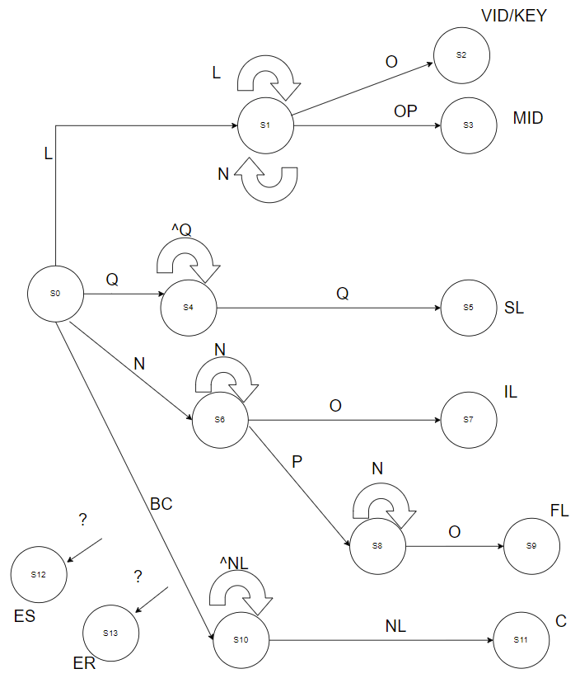

### **PART 3: TT – Transition Table (2 marks)**

**Activity:** Now, it is possible to define the TT for these lexemes:

**Answer (Transition Table):**

|  |  |  |  |  |  |  |  |  |  |
| --- | --- | --- | --- | --- | --- | --- | --- | --- | --- |
| **Current State** | **Input Symbol** | | | | | | | | **State Type** |
|  | **[a-z][A-Z]** | **[0-9]** | **“** | **#** | **.** | **(** | **O** | **NL** |  |
| **0** | **1** | **6** | **4** | **10** | **IS** | **IS** | **IS** | **IS** | **NOAS [0]** |
| **1** | **1** | **1** | **2** | **2** | **2** | **3** | **2** | **2** | **NOAS [1]** |
| **2** | **IS** | **IS** | **IS** | **IS** | **IS** | **IS** | **IS** | **IS** | **VID [2]** |
| **3** | **IS** | **IS** | **IS** | **IS** | **IS** | **IS** | **IS** | **IS** | **MID [3]** |
| **4** | **4** | **4** | **5** | **4** | **4** | **4** | **4** | **4** | **NOAS [4]** |
| **5** | **IS** | **IS** | **IS** | **IS** | **IS** | **IS** | **IS** | **IS** | **SL [5]** |
| **6** | **ES** | **6** | **ES** | **7** | **8** | **7** | **7** | **7** | **NOAS [6]** |
| **7** | **IS** | **IS** | **IS** | **IS** | **IS** | **IS** | **IS** | **IS** | **IL [7]** |
| **8** | **ES** | **8** | **ES** | **ES** | **8** | **8** | **8** | **8** | **NOAS [8]** |
| **9** | **IS** | **IS** | **IS** | **IS** | **IS** | **IS** | **IS** | **IS** | **FL [9]** |
| **10** | **10** | **10** | **10** | **10** | **10** | **10** | **10** | **11** | **NOAS [10]** |
| **11** | **IS** | **IS** | **IS** | **IS** | **IS** | **IS** | **IS** | **IS** | **C [11]** |
| **12** | **IS** | **IS** | **IS** | **IS** | **IS** | **IS** | **IS** | **IS** | **Error [12]** |
| **13** | **IS** | **IS** | **IS** | **IS** | **IS** | **IS** | **IS** | **IS** | **Error [13]** |

[1] Adapted from resources developed by Prof. Svillen Ranev (Algonquin College, 2019)